Parish of St Andrew’s, Buckland Monachorum and the
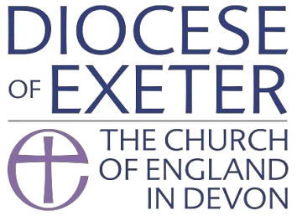
Church of the Holy Spirit, Milton Combe
Parish statement on Domestic Abuse
Policy for Responding to Domestic Abuse
All forms of domestic abuse are wrong and must stop. We are committed to promoting and supporting environments which:
• ensure that all people feel welcomed, respected and safe from abuse;
• protect those vulnerable to domestic abuse from actual or potential harm;
• recognise equality amongst people and within relationships;
- enable and encourage concerns to be raised and responded to appropriately and consistently.
We recognise that:
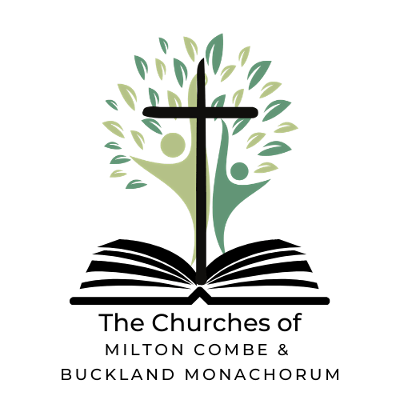
• all forms of domestic abuse cause damage to the survivor and express an imbalance of power in the relationship;
• all survivors (regardless of age, disability, gender, racial heritage, religious belief, sexual orientation or identity) have the right to equal protection from all types of harm or abuse;
• domestic abuse can occur in all communities;
• domestic abuse may be a single incident, but is usually a systematic, repeated pattern which escalates in severity and frequency;
- domestic abuse, if witnessed or overheard by a child, is a form of abuse by the perpetrator of the abusive behaviour;
- working in partnership with children, adults and other agencies is essential in promoting the welfare of any child or adult suffering abuse.
In all our activities:
• We will value, listen to and respect both survivors and alleged or known perpetrators of domestic abuse.
In our publicity:
• We will raise awareness about other agencies, support services, resources and expertise, through providing information in public and women-only areas of relevance to survivors, children and alleged or known perpetrators of domestic abuse.
When concerns are raised we will:
• ensure that those who have experienced abuse can find safety and informed help;
• work with the appropriate statutory bodies during an investigation into domestic abuse, including when allegations are made against a member of the church community.
When in our care we will:
• ensure that informed and appropriate pastoral care is offered to any child, young person or adult who has suffered abuse;
• identify and outline the appropriate relationship of those with pastoral care responsibilities with both survivors and alleged or known perpetrators of domestic abuse.
If you have any concerns or need to talk to someone please contact Trish Topham at: safeguarding@bucklandchurchdevon.co.uk

